

*shell programming lab*

aSsignment -1

**SUBMITTED BY: SUBMITTED TO:**

**AYUSH KUMAR JHA Dr. Dhiviya Rose**

**SAP ID - 500086400**

**Enrollment no - R200220083**

**B.C.A -I.O.T.**

**Experiment 1 Lab Manual**

**Title: Familiarity with Linux Environment**

**Objective: Revision of basic commands and familiarity with vi editor.**

1. Practice the following commands:

{ who, whoami, clear, man, ls (with the options-a, c, d, m, p, r, f, x), pwd, mkdir, cd, rmdir, cat (to create a file; to see the contents of a file; and to create copies), sort (to sor the content of a file in both- ascending and descending order), cp, mv, rm, wc, (i.e. word command with the options- c, l, w), head, tail }

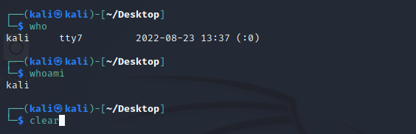

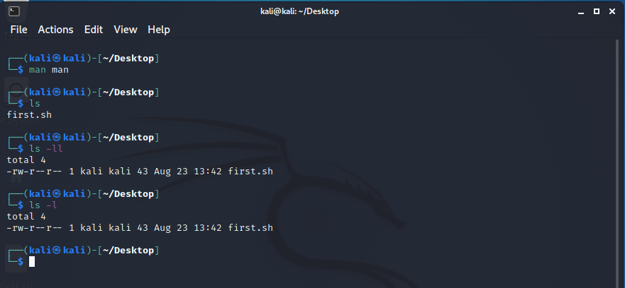

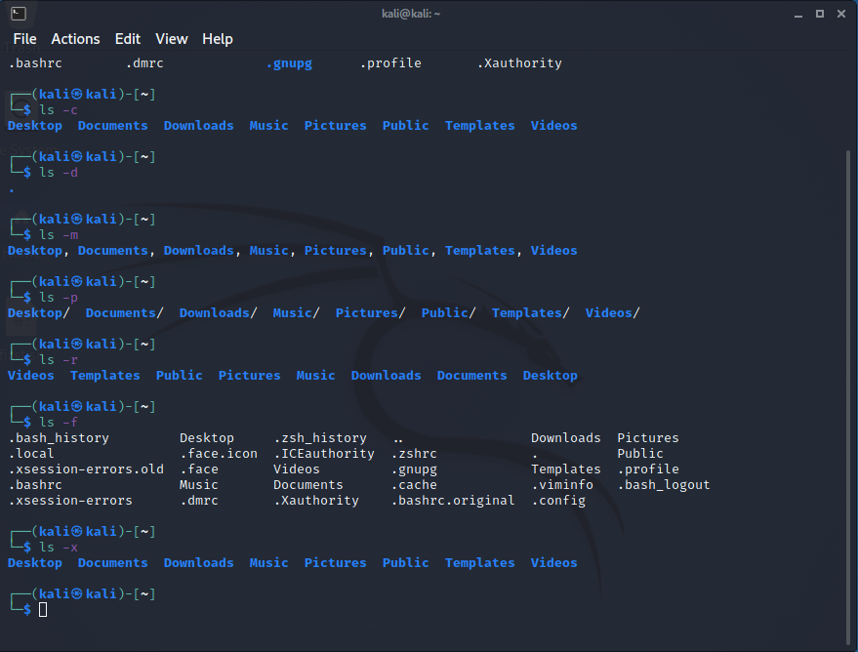

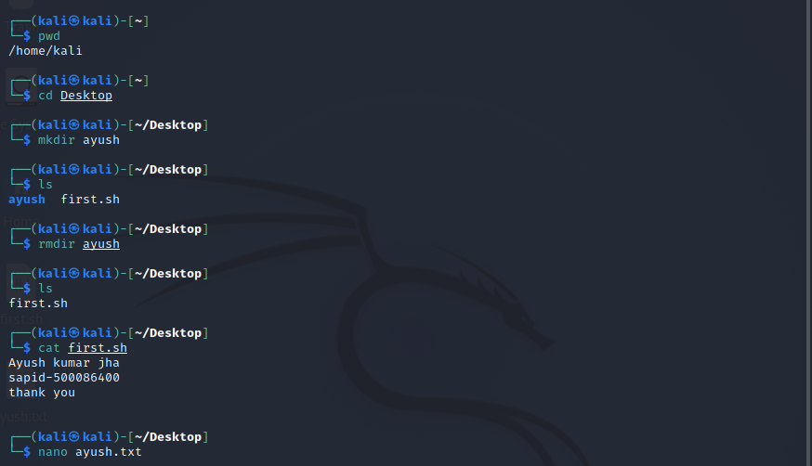

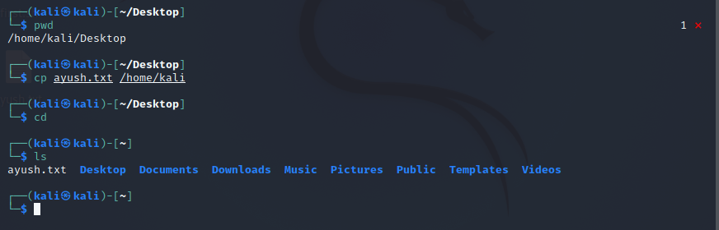

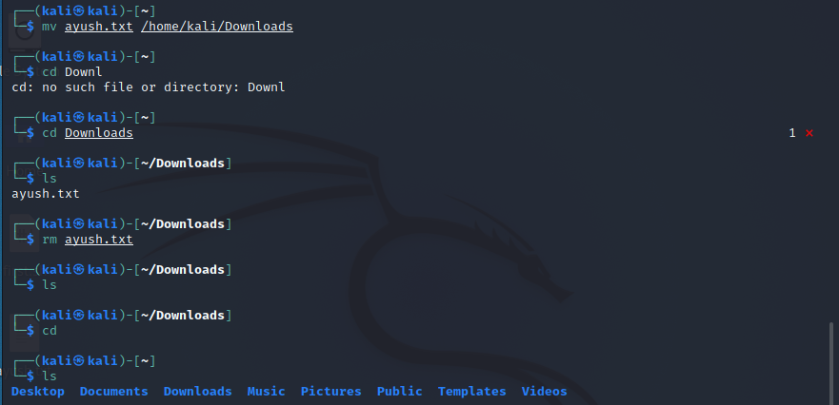

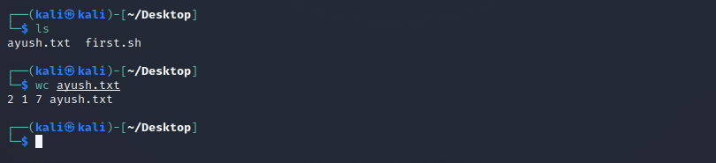

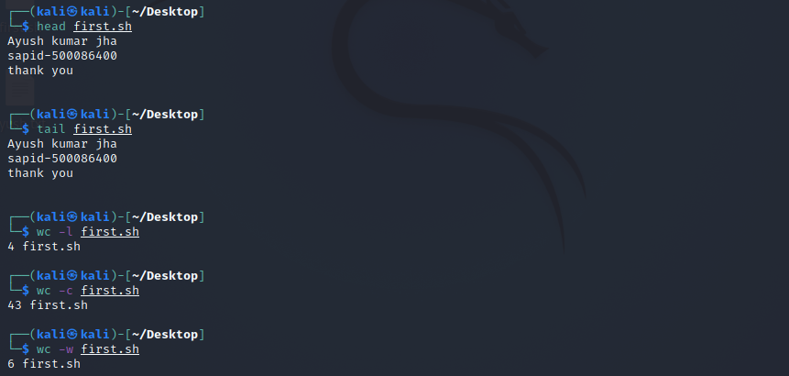

1. Practice the following vi/vim commands:

{ Inserting and replacing commands- (i, I, a, A, o, O), Cursor movement in vi- (l, k, j, h), Enter (or) n Enter- (n+, n-, 0 ), Deleting the text from vi- (x, X, nx, nX, dw, ndw, db, ndb), Saving and quiting from vi- (q, w, wq, q!, x) Inserting and replacing commands- i, I, a, A, o, O Deleting the text from vi- (x, X, nx, nX, dw, ndw, db, ndb), Undoing the mistakes-(u, :redo), Ending the editing session by using ZZ and :wq, Moving the cursor by characters and words- (f (character), F(character), w/W, b/B), Moving the cursor by sentences and paragraphs, Moving the cursor within the screen, Searching for a character and string }

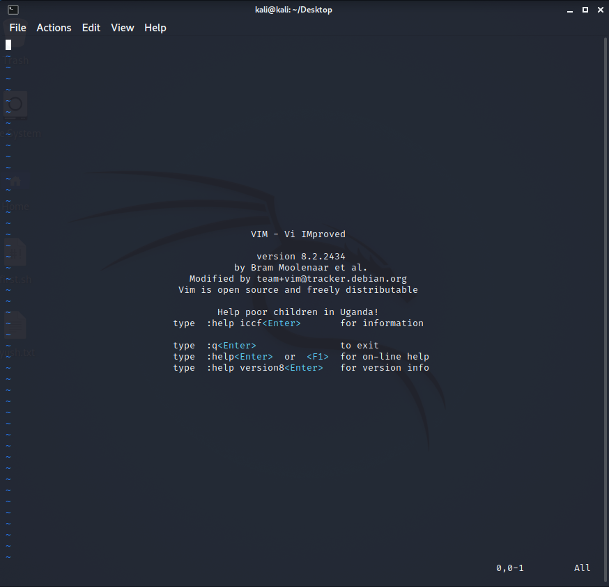

i : This key is used to Insert characters to left of cursor .

I : This key is used to Insert characters at beginning of line.

a : This key is used to Insert characters to right of cursor.

A : This key is used to put the cursor after at the end of the line.

o : This key is used to put the cursor below the line.

O : This key is used to puts the cursor above the line.

h: This key is used to move left one character.

j: This key is used to move down one line.

k: This key is used to move up one line.

l: This key is used to move right one character.

x: This key is used to delete character at the cursor.

nx: This key is used to delete the number of characters specified by n.

nX: This key is used to delete n characters before the current character.

dw: This key is used to delete from the current cursor location to the next word.

Ctrl +h : This key is used to delete the character before the cursor during insert mode.

Ctrl + n : This key is used to insert next match before the cursor during insert mode.

:q : This key is used to quit the Vim.

:w : This key is used to save the file.

:wq : This key is used to write (save) and quit.

:q! : This key is used to quit and throw away unsaved changes.

x: This key is used to save file and exit.

u : This key is used to undo previous command .

redo: This key is used to redo a change.

w/W: This key is used to jump forwards to the start of the word.

b/B: This key is used to jump backwards to the start of the word.

f: This key is used to find character.

/string : This key is used to search for string

/string : This key is used to search for string